Lab - Troubleshoot Inter-VLAN RoutingTopology

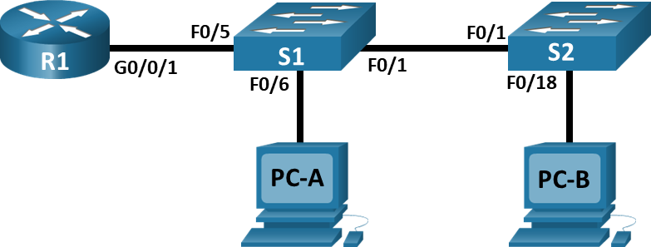

# Addressing Table

| Device | Interface | IP Address | Subnet Mask | Default Gateway |
| --- | --- | --- | --- | --- |
| R1 | G0/0/1.3 | 10.3.0.1 | 255.255.255.0 | N/A |
| R1 | G0/0/1.4 | 10.4.0.1 | 255.255.255.0 | N/A |
| R1 | G0/0/1.13 | 10.13.0.1 | 255.255.255.0 | N/A |
| S1 | VLAN 3 | 10.3.0.11 | 255.255.255.0 | 10.3.0.1 |
| S2 | VLAN 3 | 10.3.0.12 | 255.255.255.0 | 10.3.0.1 |
| PC-A | NIC | 10.4.0.50 | 255.255.255.0 | 10.4.0.1 |
| PC-B | NIC | 10.13.0.50 | 255.255.255.0 | 10.13.0.1 |

# VLAN Table

|  |  |  |
| --- | --- | --- |
| VLAN | Name | Interface Assigned |
| 3 | Management | S1: VLAN 3  S2: VLAN 3 |
| 4 | Operations | S1: F0/6 |
| 7 | ParkingLot | S1: F0/2-4, F0/7-24, G0/1-2  S2: F0/2-17, F0/19-24, G0/1-2 |
| 8 | Native | N/A |
| 13 | Maintenance | S2: F0/18 |

# Objectives

Part 1: Evaluate Network Operation

Part 2: Gather information, create an action plan, and implement corrections

# Background / Scenario

**Instructor Note**: Preconfiguration scripts for all the devices are documented below. Cut and paste or otherwise use these to pre-configure the equipment for the student.

**Router R1**

enable

configure terminal

hostname R1

no ip domain lookup

enable secret class

line con 0

password cisco

login

logging synch

line vty 0 4

password cisco

login

service password-encryption

banner motd $ Authorized Users Only! $

interface g0/0/1

no shut

interface g0/0/1.3

encap dot1q 3

ip add 10.3.0.1 255.255.255.0

interface g0/0/1.4

encap dot1q 4 native

ip address 10.4.0.1 255.255.255.0

interface g0/0/1.8

! encap dot1q 8 native

encap dot1q 8

interface g0/0/1.13

encap dot1q 13

ip address 10.13.0.1 255.255.255.0

end

**Switch S1**

enable

config terminal

hostname S1

no ip domain-lookup

enable secret class

line con 0

password cisco

login

logging synch

line vty 0 15

password cisco

login

service password-encryption

banner motd $ Authorized Users Only! $

vlan 3

name Management

vlan 4

name Operations

vlan 7

name ParkingLot

vlan 8

name Native

!vlan 13

! name Maintenance

interface vlan 3

ip address 10.3.0.11 255.255.255.0

no shut

exit

ip default-gateway 10.3.0.1

interface range f0/2-4, f0/7-24, G0/1-2

switchport mode access

switchport access vlan 7

shutdown

interface f0/1

switchport mode trunk

! switchport trunk native vlan 8

! switchport trunk allowed vlan add 3

switchport trunk allowed vlan 4,8,13

no shutdown

interface f0/6

switchport mode access

switchport access vlan 4

no shutdown

interface f0/5

switchport mode access

! default interface fa0/5

! switchport mode trunk

switchport trunk native vlan 8

! switchport trunk allowed vlan 3,4,8,13

switchport access vlan 3

no shut

end

**Switch S2**

enable

config terminal

hostname S2

no ip domain-lookup

enable secret class

line con 0

password cisco

login

logging synch

line vty 0 15

password cisco

login

service password-encryption

banner motd $ Authorized Users Only! $

vlan 3

name Management

vlan 4

name Operations

vlan 7

name ParkingLot

vlan 8

name Native

vlan 13

name Maintenance

interface vlan 3

ip address 10.3.0.12 255.255.255.0

no shut

interface range f0/2-17, f0/19-24, G0/1-2

switchport mode access

switchport access vlan 7

shutdown

interface f0/18

switchport mode access

switchport access vlan 13

interface f0/1

switchport mode trunk

switchport trunk native vlan 8

switchport trunk allowed vlan 4,8

! switchport trunk allowed vlan add 3,13

ip default-gateway 10.3.0.1

end

Your instructor has preconfigured all the network equipment and has included intentional errors that are keeping the inter-VLAN routing from working. Your task is to evaluate the network and identify and correct the configuration errors to restore full connectivity. You may find errors with the configurations which are not directly related to inter-VLAN routing that impact the ability of the network devices to perform this function.

**Note:** The design approach used in this lab is to assess your ability to configure and troubleshoot inter-VLAN routing only. This design may not reflect networking best practices.

**Note**: The router used with CCNA hands-on labs it the Cisco 4221 with Cisco IOS XE Release 16.9.4 (universalk9 image). The switches used in the labs are Cisco Catalyst 2960s with Cisco IOS Release 15.2(2) (lanbasek9 image). Other routers, switches, and Cisco IOS versions can be used. Depending on the model and Cisco IOS version, the commands available and the output produced might vary from what is shown in the labs. Refer to the Router Interface Summary Table at the end of the lab for the correct interface identifiers.

**Note**: Ensure that the routers and switches have been erased and have no startup configurations. If you are unsure contact your instructor.

**Instructor Note**: Refer to the Instructor Lab Manual for the procedures to initialize and reload devices

# Required Resources

* 1 Router (Cisco 4221 with Cisco IOS XE Release 16.9.4 universal image or comparable)
* 2 Switches (Cisco 2960 with Cisco IOS Release 15.2(2) lanbasek9 image or comparable)
* 2 PCs (Windows with a terminal emulation program, such as Tera Term)
* Console cables to configure the Cisco IOS devices via the console ports
* Ethernet cables as shown in the topology

**NOTES:**

|  |  |  |  |
| --- | --- | --- | --- |
| **From** | **To** | **Ping result** | **Reason?** |
| S1 | S2 VLAN 3 | 0/5 | Nativ VLAN mismatched on F0/1 |
|  |  |  |  |

Error message on S1 and S2, “Native VLAN mismatched”.

* Used “show interface trunk”. Native vlan on s1 was assigned to vlan 1, while native vlan on s2 was assigned to vlan 8. Configured so both native vlans was assigned to vlan 8.

“show interface trunk”, on s1 and s1, showed missing vlans.

* On s1, missed vlan 13 and 8 on fa0/5
* On s1, missed vlan 3 and 4 on fa0/1
* On s2, missed vlan 3 and 13 on fa0/1

Vlan 13 didn’t exist on s1 (for trunking capability so that PC-B to be able to communicate with the router, and communication between s1 and s2)

* Configured vlan 13 with appropriate interfaces on s1.

R1 native vlan 8…? Not sure the reason